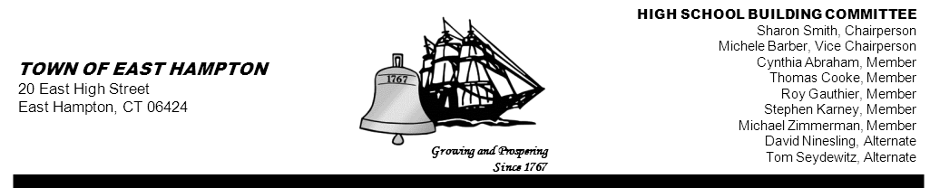

HIGH SCHOOL—ADDITION & RENOVATE-AS-NEW
HIGH SCHOOL BUILDING COMMITTEE MEETING
High School Library/Media Center
15 North Maple Street, East Hampton, CT 06424
AGENDA
Thursday, January 17, 2013, 6:30 p.m.

1. Call to Order

2. Public Remarks

3. Review and acceptance of minutes from previous meeting(s)

4. Discussion on the 01/15/13 Public Meeting

5. Public Remarks

6 . Motion to adjourn the meeting

7 . Adjournment

Cc: John Fidler
Kevin Reich
Keith Klemonski
Michael Maniscalco
Susan Weintraub
Jeff Jylkka
James Giuliano
Glenn Gollenberg
Amy Samuelson
Amy Christmas
Glenn Gemma
Mark Winzler
Cathy Sirois (posting)
Sandi Wieleba (posting)

